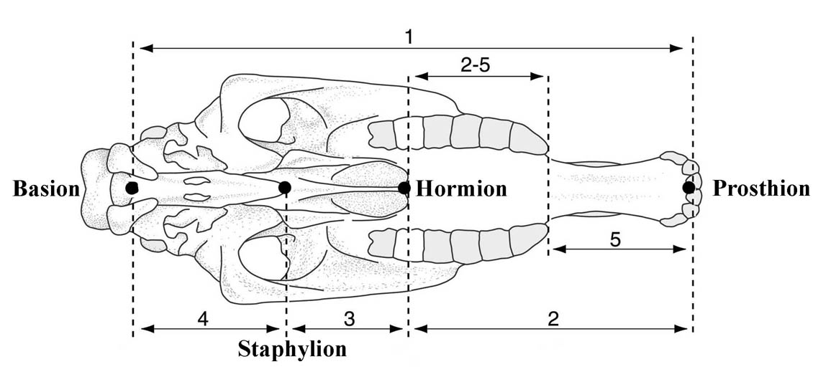

Figure S2. Schematic occlusal view of an *Equus* cranium. 1: basilar length. 2: overall palatal lengh. 2-5: palatal length sensu stricto. 3: vomerine length. 4: post-vomerine length. 5. muzzle length. Measurements defined in Eisenmann 1986 [17].